**TRANSMISSION-BASED PRECAUTIONS TO PREVENT DISEASE TRANSMISION**

**Objective**

1. Differentiate between Contact, Droplet and Airborne precautions
2. Explain how Transmission-Based Precautions are used with Standard Precautions
3. Describe how procedures for airborne differ from those for contact and droplet Precautions.

[](https://www.google.com/url?sa=i&url=https%3A%2F%2Fwww.dreamstime.com%2Fstop-infectious-disease-covid-information-banner-outbreak-coronavirus-ncov-global-epidemic-threatens-people-s-health-image178161095&psig=AOvVaw2Ukq6KB4Sxu9KlkV9hyIpa&ust=1588670217261000&source=images&cd=vfe&ved=0CAIQjRxqFwoTCMi3oPjvmekCFQAAAAAdAAAAABAJ)

Additional precautions are used in addition to standard precautions to prevent the transmission of infection**.** In module 1 and 2 you learnt that standard precautions are the work practices required to achieve a basic level of infection prevention and control, and that they are the minimum infection prevention and control practices that must be used at all times for all patients in all situations.

Reflection on what you learnt in module 1 and 2: Standard precautions consist of the following practices:

* Hand hygiene before and after all patient contact
* The use of personal protective equipment, which may include gloves, impermeable gowns, plastic aprons, masks, face shields and eye protection
* The safe use and disposal of sharps
* Appropriate use of skin disinfectants
* Reprocessing of reusable instruments and equipment
* Routine environmental cleaning
* waste management
* Appropriate handling of linen.
* **Respiratory hygiene and cough etiquette-you will learn in this module

[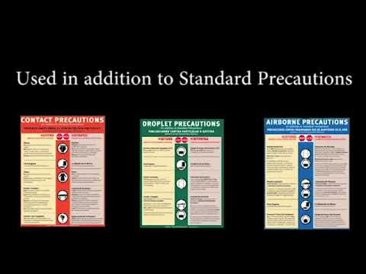](https://www.google.co.ke/url?sa=i&url=https%3A%2F%2Fwww.youtube.com%2Fwatch%3Fv%3DnF8OM9Irmcs&psig=AOvVaw06_lDw1wE1bBTNkJnOVunD&ust=1588322805956000&source=images&cd=vfe&ved=0CAIQjRxqFwoTCOiLrtnhj-kCFQAAAAAdAAAAABAP)

Transmission-based precautions (TBPs) are used in addition to standard precautions when standard precautions alone may be insufficient to prevent transmission of infection. TBPs are used for patients known or suspected to be infected with highly transmissible pathogens that can transmit or cause infection. Both Transmission -based and standard precautions protect everyone -patients, residents, visitors, staff, and you. If you are careless, everyone’s safety is at risk.

Transmission-based precautions are based upon the mode of transmission of the infectious agent. You **must** understand how certain infections are spread e.g. influenza, Tuberculosis, hepatitis A, B and C, gastrointestinal infections e.g. Diarrhea, vomiting, COVID-19. This helps you understand the different types of Transmission -based precautions

The following are the routes of transmission.

* Contact transmission (direct or indirect), e.g., viral gastroenteritis, Clostridium difficile, MRSA, scabies,
* Droplet transmission, e.g., influenza, pertussis (whooping cough), rubella, COVID-19
* Airborne transmission, e.g., pulmonary tuberculosis, chickenpox, measles

Transmission-Based Precautions (TBPs) are not required for patients with bloodborne viruses, such as HIV, hepatitis B virus or hepatitis C virus.

To minimize the exposure time of other people in office-based practices or hospital waiting rooms, people identified as at risk of transmitting droplet or airborne diseases (for example, a child with suspected chickenpox or COVID-19) should be attended to immediately and placed into appropriate transmission-based precautions to prevent further spread of disease. They are commonly called “isolation precautions.” These precautions involve the **use of protective barriers.**

[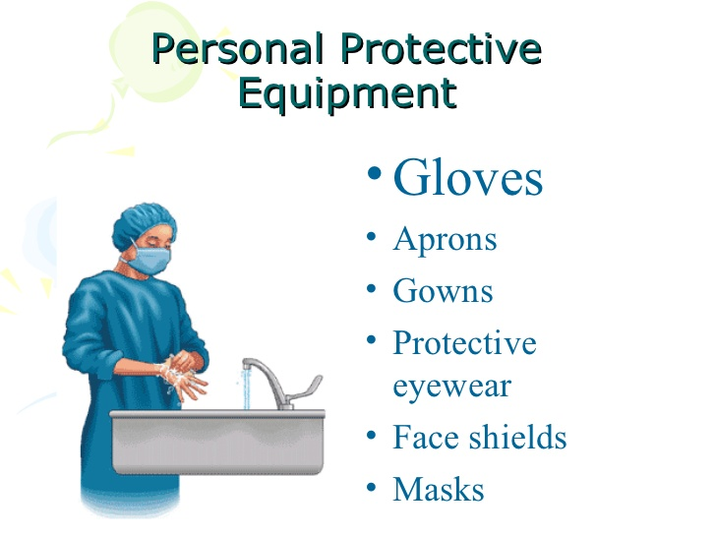](https://www.google.com/url?sa=i&url=https%3A%2F%2Ftwitter.com%2Fstarttalking1&psig=AOvVaw2XWYGFMnZI8ue9ih9SkfW3&ust=1588670010503000&source=images&cd=vfe&ved=0CAIQjRxqFwoTCIjL7J7vmekCFQAAAAAdAAAAABAU)[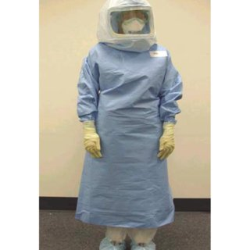](https://www.google.com/url?sa=i&url=https%3A%2F%2Fwww.researchgate.net%2Ffigure%2FHealthcare-worker-dressed-in-T4-Stryker-personal-protection-system-PPS-The-PPS-is-worn_fig2_7414403&psig=AOvVaw1SFSlENnMWD7QYcASMu8W_&ust=1588668608498000&source=images&cd=vfe&ved=0CAIQjRxqFwoTCMCthfTpmekCFQAAAAAdAAAAABAO)

**Signage**

Signage should be positioned prominently outside the room of a patient in TBPs. This is to ensure staff and visitors do not enter without appropriate PPE. Note: visitors may not always be required to wear PPE when visiting patients in TBPs.

[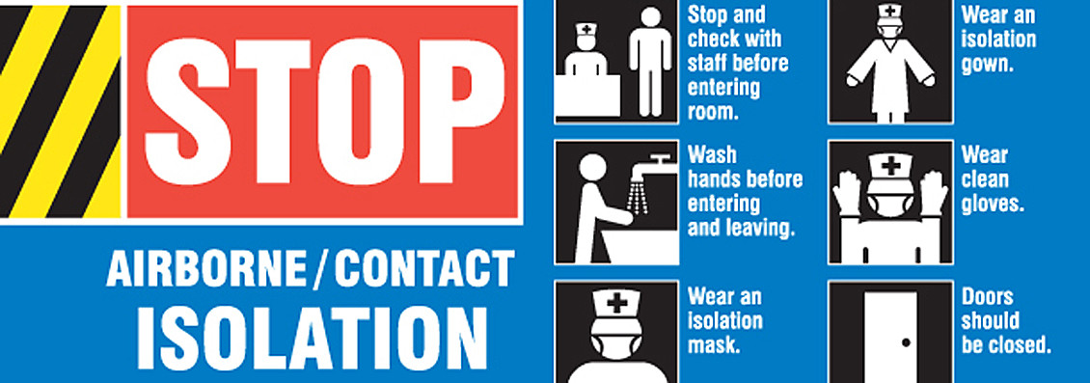](https://www.google.com/url?sa=i&url=https%3A%2F%2Fwww.lhsigns.com%2Fidentify-infection-hazards-with-medical-signage.html&psig=AOvVaw0n-M1HglKKWMLhXMqLJ_0M&ust=1588667844232000&source=images&cd=vfe&ved=0CAIQjRxqFwoTCJC7vobnmekCFQAAAAAdAAAAABAI)

**RULES FOR ISOLATION PRECAUTION**

* Collect all needed items before entering the room.
* Do not contaminate equipment and supplies. Floors are contaminated so is any object on the floor that falls on the floor
* Clean floors with mops wetted with a disinfectant solution. Floor dust is contaminated.
* Prevent drafts. Drafts can carry some microbes in the air
* Use paper towels to handle contaminated items
* Remove items from the room in leak proof plastic bags
* Double-bag items if the outside of the bag is or can be contaminated
* Safe laundry handling when removing and transporting disposable and re-usable items
* Return reusable dishes, drinking vessels, eating utensils and trays to the food service department
* Discard disposable dishes, drinking vessels, eating utensils and trays in the waste container in the persons room.
* Do not touch your hair, nose, mouth, eyes or other body parts
* Do not touch any clean area or objects if your hands are contaminated
* Wash your hands if they are visibly dirty or contaminated with blood, body fluid, secretions or excretions
* Place clean items on paper towels
* Do not shake linen
* Use paper towels to turn faucets on and off
* Use paper towel to open the door to the persons room.

Discard it after use

* If you have any cuts, open skin areas, cover them with addressing. Also inform your manager.
* If you have a sore throat, vomiting or diarrhea, inform your manager before reporting to work.

[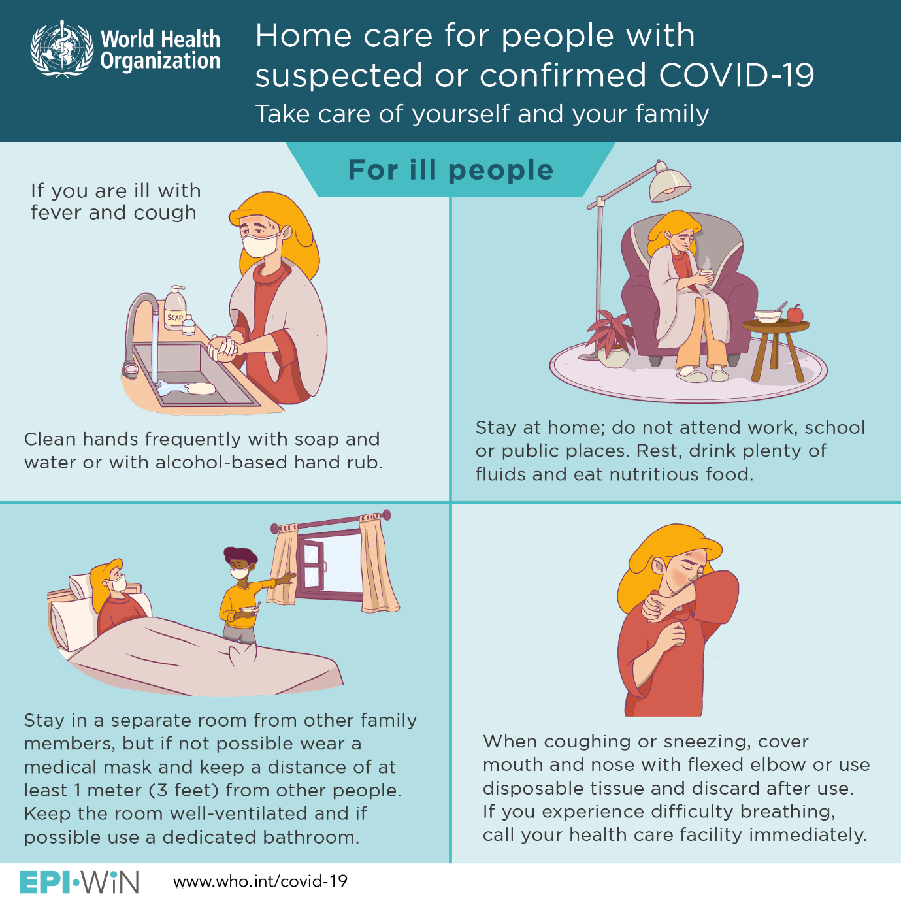](https://www.google.com/url?sa=i&url=https%3A%2F%2Fwww.who.int%2Femergencies%2Fdiseases%2Fnovel-coronavirus-2019%2Fadvice-for-public&psig=AOvVaw24LBphIOxzd-TK24JxBMvs&ust=1588668009106000&source=images&cd=vfe&ved=0CAIQjRxqFwoTCKCL7NjnmekCFQAAAAAdAAAAABAJ)

1. **Contact precaution**

Used for persons with known or suspected infections or conditions that increase the risk of contact transmission.

These are diseases caused by microorganisms that are spread by person to person contact or indirect contact with contaminated objects Examples: rotavirus, draining abscesses and wounds and COVID-19.

Use the following measure in addition to standard precautions when in contact with individuals known or suspected of having diseases spread by direct or indirect contact

* A single room is preferred. Do the following if a room is shared with another person not infected with the same agent:
* Keep the privacy curtain between the beds closed
* Draw the privacy curtain between beds to minimize opportunities for direct contact.
* Change PPE between patients. Do so regardless of whether 1 or both persons are on contact precautions
* Wear gloves and gown before contact with the individual, surfaces, or objects within his/her environment.
* Remove gloves and gown and practice hand hygiene before leaving the persons room. Make sure your clothing and skin do not touch potentially contaminated surfaces when removing (outer side of gown and gloves are contaminated)

**Patient transport**

* Limit transport and movement of patients outside of the room to medically necessary purposes.
* When transport or movement in any healthcare setting is necessary, ensure that infected areas of the patient’s body are contained and covered.
* Remove and dispose of contaminated PPE and perform hand hygiene prior to transporting patients on Contact Precautions.
* Don clean PPE to handle the patient at the transport destination.

**Care equipment**

* Follow standard precautions Handle patient-care equipment and instruments/devices according to Standard Precautions
* All re-usable items taken into the individual’s room or home should be cleaned and disinfected before removed.
* Disposable items should be discarded at point of use. Use disposable equipment when possible. If possible, leave non-disposable in the person’s room
* Clean and disinfect non-disposable and multiple use equipment before use on another person

[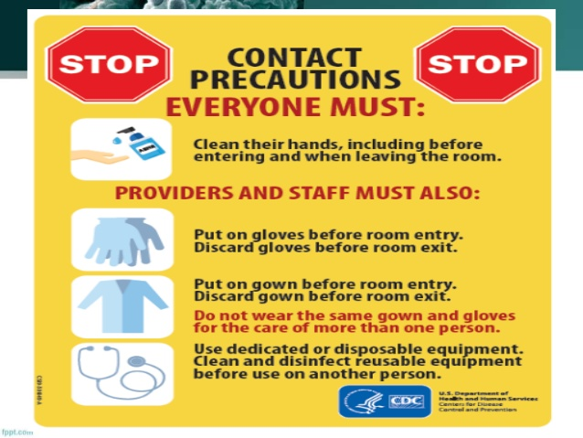](https://www.google.co.ke/url?sa=i&url=https%3A%2F%2Fwww.slideshare.net%2FRakeshPrasadSah%2Ftransmission-based-precautions-tbp-by-dr-rakesh-prasad-sah&psig=AOvVaw0vjYSzN5xAYhfFH56uhVrL&ust=1588325159726000&source=images&cd=vfe&ved=0CAIQjRxqFwoTCJiJtPHvj-kCFQAAAAAdAAAAABAb)

[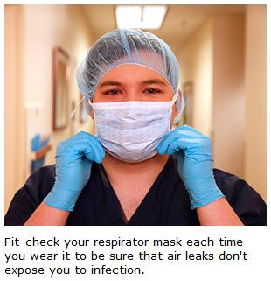](https://www.google.com/url?sa=i&url=https%3A%2F%2Fwww.mountnittany.org%2Farticles%2Fhealthsheets%2F6464&psig=AOvVaw1SFSlENnMWD7QYcASMu8W_&ust=1588668608498000&source=images&cd=vfe&ved=0CAIQjRxqFwoTCMCthfTpmekCFQAAAAAdAAAAABAT)

1. **Droplet precaution**

Used for persons known or suspected to be infected with pathogens transmitted by respiratory droplets. Such droplets come from coughing, sneezing, or talking.

Examples of when it is appropriate to start empiric application of droplet precautions include, but are not limited to, suspicion of the following illnesses:

* COVID -19
* Influenza (flu)
* Pertussis (whooping cough)
* Bacterial meningitis
* Rubella (German measles)
* *Mycoplasma pneumoniae*
* Mumps
* Small pox

**Patient or resident placement**

* A single room is preferred. Do the following if a room is shared with another person not infected with the same agent:
* Keep the privacy curtain between the beds closed
* Draw the privacy curtain between beds to minimize opportunities for direct contact.
* Change PPE between patients. Do so regardless of whether 1 or both persons are on droplet precautions
* In addition to standard precautions, wear a surgical mask when within 3 feet of persons known or suspected of having diseases spread by droplets

**Patient transport**

* Limit transport and movement of patients outside of the room to medically necessary purposes.
* When transport or movement in any healthcare setting is necessary, have the person wear a mask
* Instruct the person to follow respiratory hygiene/cough etiquette
* No mask is required for a person transporting the person.

**Respiratory hygiene/cough etiquette:**

The following measures to contain respiratory secretions are recommended for all individuals with signs and symptoms of a respiratory infection.

* Cover the nose and mouth to cough or when cough or sneeze
* Use tissues to contain respiratory secretions.
* Dispose of the tissue after use in the nearest waste container.
* Use in the nearest waste receptacle to
* Perform hand hygiene after contact with respiratory secretions and contaminated objects/materials.
* Provide tissues and no-touch receptacles for used tissue disposal.
* Provide visitors with masks

[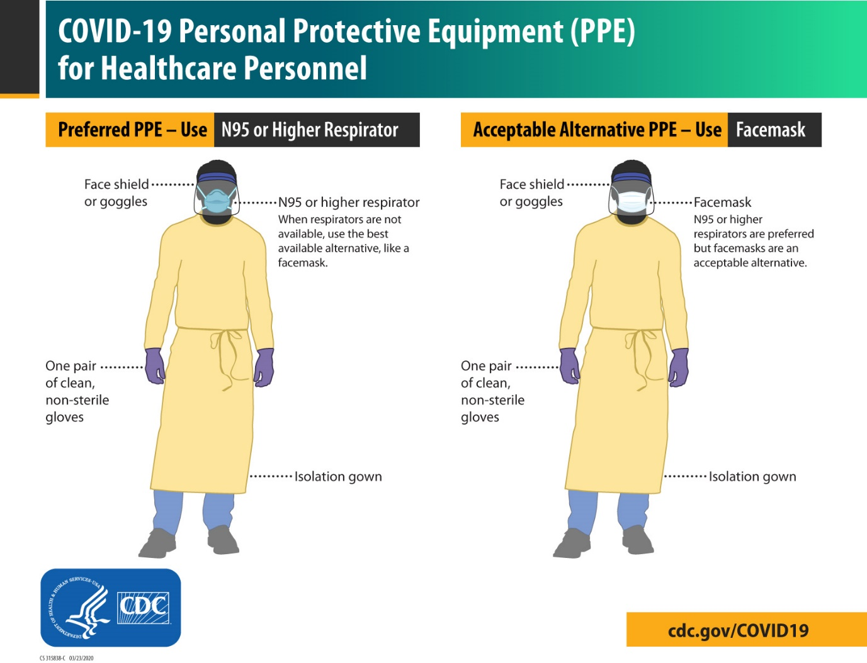](https://www.google.co.ke/url?sa=i&url=https%3A%2F%2Fwww.cdc.gov%2Fcoronavirus%2F2019-ncov%2Fhcp%2Finfection-control-recommendations.html&psig=AOvVaw3IqPOpggDxbAIx0mYv4Xq8&ust=1588327418931000&source=images&cd=vfe&ved=0CAIQjRxqFwoTCKj25fDyj-kCFQAAAAAdAAAAABAD)

1. **Airborne precautions**

Used for persons known or suspected to be infected with pathogens transmitted person-to person by the airborne route. (Examples: Tuberculosis (TB), measles, antibiotic- resistant bacteria).

Use the following measures in addition to standard precautions when in contact with individuals known or suspected to have diseases spread by fine particles dispersed by air currents

**Patient placement**

* The person is Placed in an AIIR (Airborne infection isolation **room** (**AIIR**) as soon as possible. If not available, the person is transferred to an agency with an AIIR
* Instruct patients with a known or suspected airborne infection to wear a surgical mask and observe Respiratory Hygiene/Cough Etiquette. Once in an AIIR, the mask may be removed; the mask should remain on if the patient is not in an AIIR.

AIIR practices include:

* All persons entering the room wear a Tuberculosis TB respirator.
* The room door is kept close except when someone enters or leaves the room
* Treatments and procedures are done in the room
* The person wears a mask during transport
* Staff susceptible to infection are restricted from entering the room.

PPE

* Always put on a NIOSH-certified fit-tested N-95 respirator just before entry to an area of shared air space and wear while in shared air space.
* Remove and discard respirator just after exiting area. The respirator may be discarded into the regular trash unless contact precautions must also be followed. In this case, place the respirator in a plastic zip-lock bag, seal and then discard into the trash. A mask or respirator is applied before entering the room

Patient/resident transport:

* Limit transport and movement of patients outside of the room to medically necessary purposes.
* When transport or movement in any healthcare setting is necessary, have the person wear a mask
* Instruct the person to follow respiratory hygiene/cough etiquette
* No mask is required for a person transporting the person.

**\*\*\*\***Polite way to ask a visitor to wear a mask if needed; “Please wear a mask. It is our policy to protect you, your family member, and others.”

[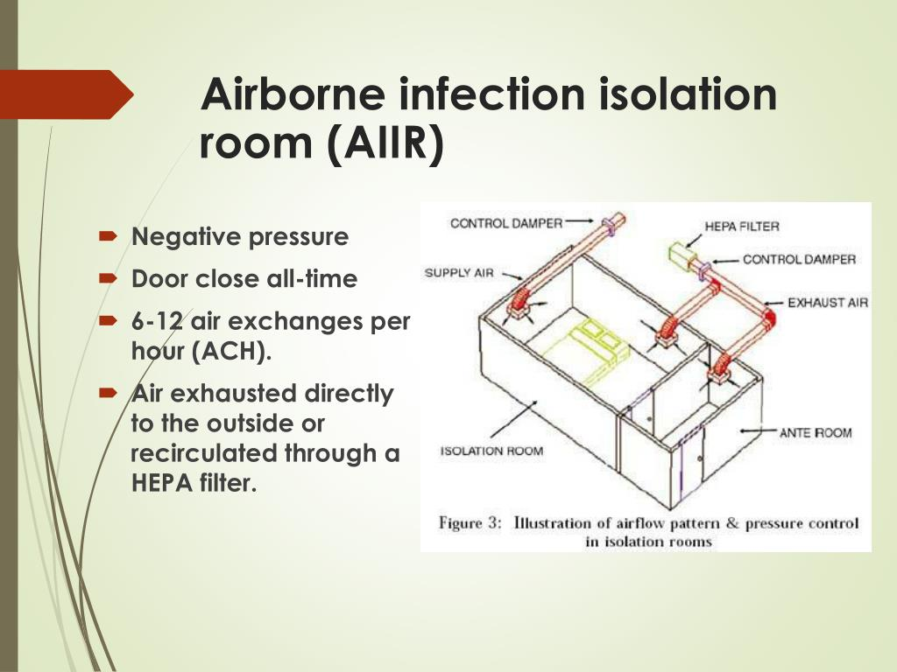](https://www.google.co.ke/url?sa=i&url=https%3A%2F%2Fwww.slideserve.com%2Fkonala%2Frecommendations-for-infection-control-for-the-practice-of-anesthesiology&psig=AOvVaw1nhw2KVI1GYbiySKDzQQL1&ust=1588327781392000&source=images&cd=vfe&ved=0CAIQjRxqFwoTCKjahZ70j-kCFQAAAAAdAAAAABAD)

**PERSONAL PROTECTIVE EQUIPMENT**

The PPE needed depends on the task, procedures and care measures, and the type of transmission -based precautions used. Sometimes only gloves are needed.

[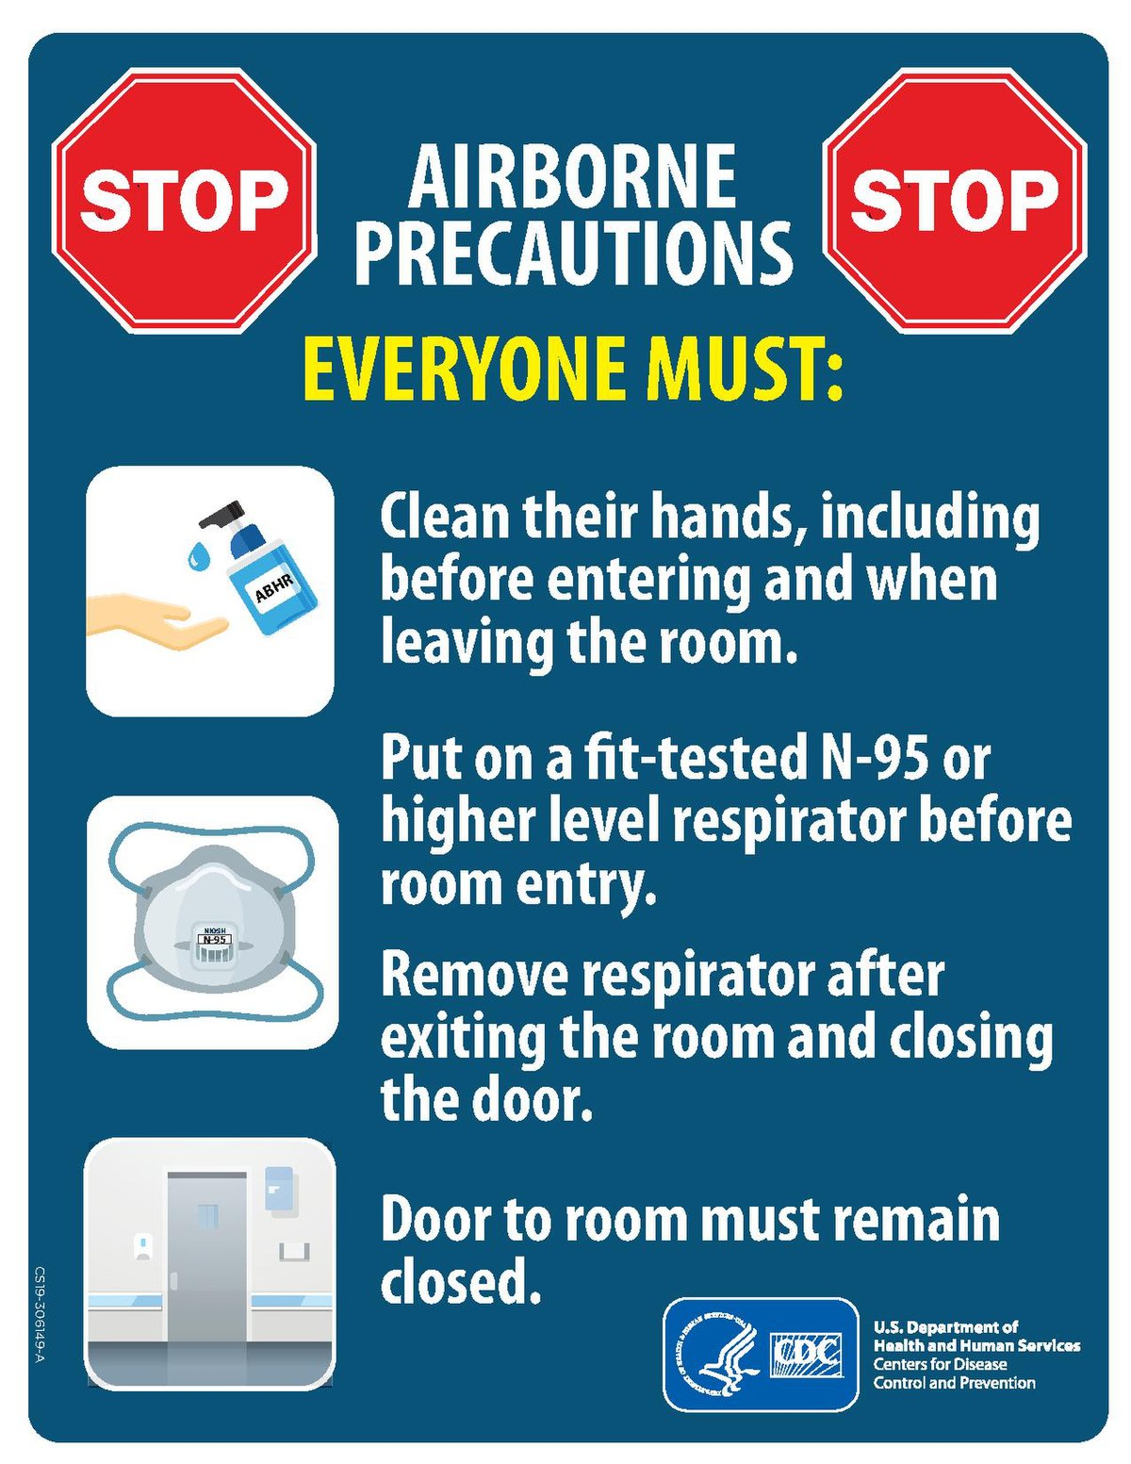](https://www.google.co.ke/url?sa=i&url=https%3A%2F%2Fen.wikipedia.org%2Fwiki%2FAirborne_disease&psig=AOvVaw0vjYSzN5xAYhfFH56uhVrL&ust=1588325159726000&source=images&cd=vfe&ved=0CAIQjRxqFwoTCJiJtPHvj-kCFQAAAAAdAAAAABAs)

**GOWNS**

* Gowns stop the spread of microbes.
* They protect your clothes and body from contact with blood, body fluids and secretions.
* They also protect against splashes and sprays.
* A gown must completely cover you from your neck to your knees. The long sleeves have tight cuffs. The gown opens at the back. It is tied at the neck and waist. The gown front and sleeves are considered *contaminated*
* Gown are used once. A wet gown is contaminated. Remove it and put on a dry one.
* Discard disposable gowns after use.

**MASKS AND RESPIRATORY PROTECTION**

You wear disposable masks:

* For protection from contact with infectious materials from the person. Respiratory secretions and sprays of blood and body fluids are examples
* When assisting with sterile procedures. This protects the person from infectious agents carried in your nose and mouth.
* A wet or moist mask is contaminated. Breathing can cause masks to become wet or moist
* Apply a new mask when contamination occurs.
* A mask fits snuggly over your nose and mouth.
* Practice hand hygiene before putting on a mask.
* To remove the mask, only touch the ties or elastic bands. The front of the mask is contaminated.

Tuberculosis respirators are worn when caring for persons with TB.

**GOGGLES AND FACE SHIELDS**

* Goggles and face shields protect your eyes nose and mouth from splashing or spraying of blood, body fluids, secretion and excretions. Slashes and sprays can occur when you give care, clean items, or dispose of fluids.
* The front (outside) of goggles or a face shield is *contaminated*. The head band, ties, or earpieces used to secure the devices are *clean.* Use them to remove the device after hand hygiene. They are safe to touch with bare hands.
* Lift the ties or earpieces from the back when removing the device.
* Discard disposablegoggles or face shield after use. Re-usable eyewear is cleaned before re-use. It is washed with soap and water. Then a disinfectant is used.

**Gloves**

Wearing gloves is most common measure for Standard Precautions and Transmission – Based Precautions.

* Apply a new pair for every person.
* Change gloves when touching moving from a contaminated body site to a clean body site.
* Change gloves when touching portable computer keyboards or other mobile equipment that is transport from room to room.
* Put on gloves last when they are worn with other PPE.
* Make sure gloves cover your wrists. If you wear a gown, gloves cover the cuffs.
* Practice hand hygiene after removing gloves.

[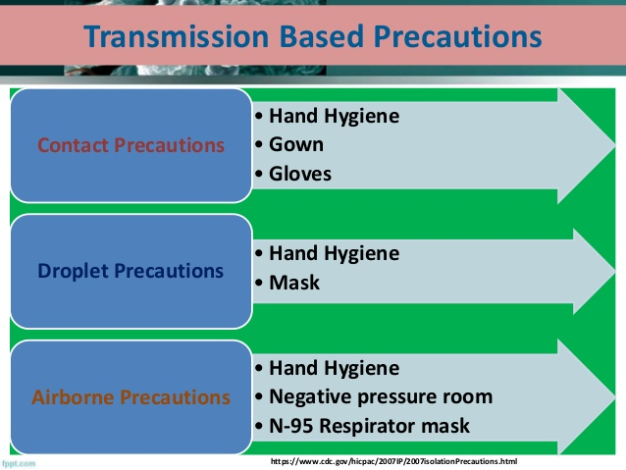](https://www.google.co.ke/url?sa=i&url=https%3A%2F%2Fwww.slideshare.net%2FRakeshPrasadSah%2Ftransmission-based-precautions-tbp-by-dr-rakesh-prasad-sah&psig=AOvVaw06_lDw1wE1bBTNkJnOVunD&ust=1588322805956000&source=images&cd=vfe&ved=0CAIQjRxqFwoTCOiLrtnhj-kCFQAAAAAdAAAAABAD)

[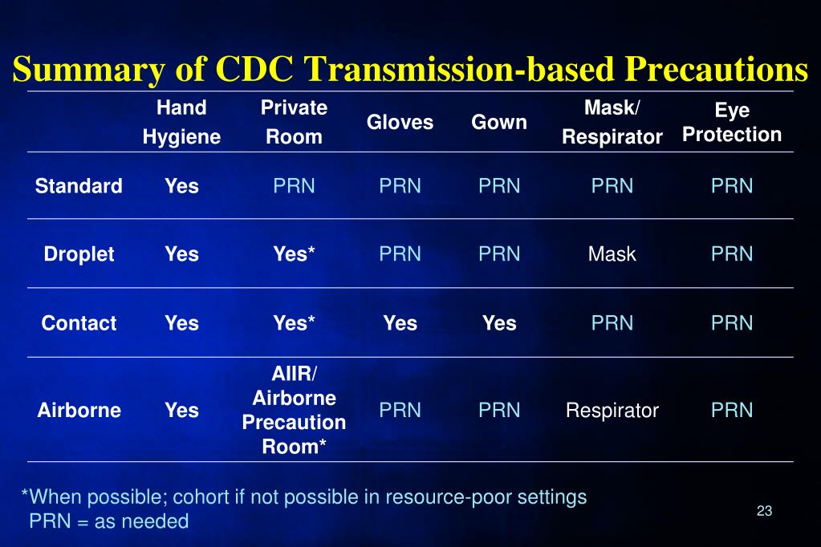](https://www.google.co.ke/url?sa=i&url=https%3A%2F%2Fwww.slideserve.com%2Fwaseemah%2Favian-and-pandemic-influenza-infection-control-perspectives&psig=AOvVaw0vjYSzN5xAYhfFH56uhVrL&ust=1588325159726000&source=images&cd=vfe&ved=0CAIQjRxqFwoTCJiJtPHvj-kCFQAAAAAdAAAAABA7)

*Prn abbreviation: meaning- \*\*****when necessary***

[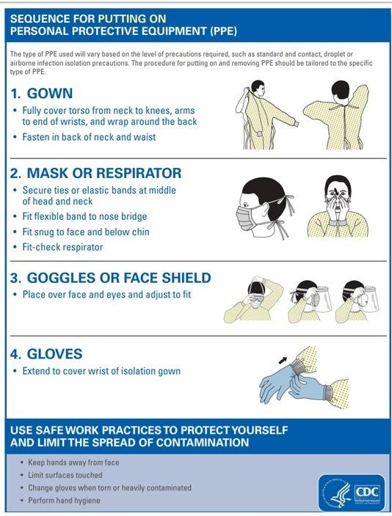](https://www.google.co.ke/url?sa=i&url=https%3A%2F%2Fwww.medscape.org%2Fviewarticle%2F926970&psig=AOvVaw3IqPOpggDxbAIx0mYv4Xq8&ust=1588327418931000&source=images&cd=vfe&ved=0CAIQjRxqFwoTCKj25fDyj-kCFQAAAAAdAAAAABAH)

[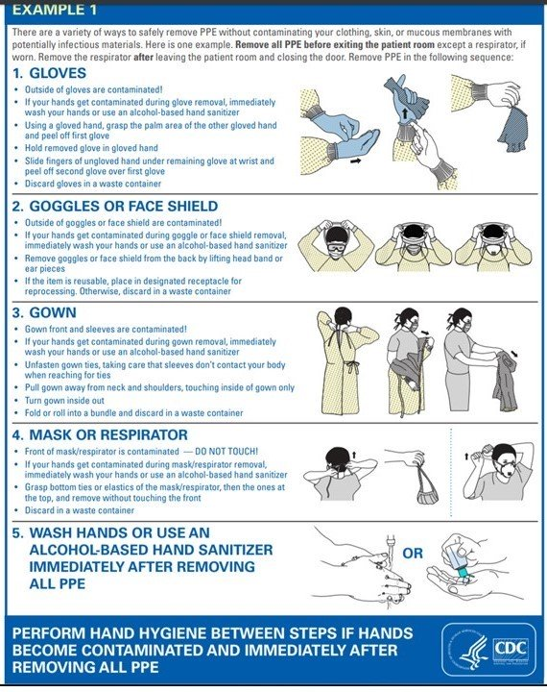](https://www.google.co.ke/url?sa=i&url=https%3A%2F%2Fwww.medscape.org%2Fviewarticle%2F926970&psig=AOvVaw3IqPOpggDxbAIx0mYv4Xq8&ust=1588327418931000&source=images&cd=vfe&ved=0CAIQjRxqFwoTCKj25fDyj-kCFQAAAAAdAAAAABAf)

**Bagging items**

Contaminated items are bagged for removal from the person’s room. Leak proof plastic bags are used. They have the *BIOHARAZRD* Symbol.

* Do not overfill the bag. Tie the bag securely. Then place it in a laundry hamper lined with a biohazard plastic bag.
* Trash is placed in a container labelled with the *BIOHARAZRD* Symbol. Follow agency policy for bagging and transporting trash, equipment and supplies.
* Usually 1 bag is needed. Double – bagging involves 2 bags. Double bagging is needed if the outside of the bag is wet, soiled, or may be contaminated.

**Transporting Persons**

Persons on Transmission – Based Precautions usually do not leave their rooms. Sometimes they go for treatments or tests.

Transport procedures vary among agencies. some require transport by bed. This prevents contaminating wheelchairs and stretchers. others use wheelchairs and stretchers.

A safe transport protects others from infection.

* Have the person wear a clean gown.
* Have a person wear a mask as required by the Transmission – Based Precautions used.
* Cover any draining wounds.
* Give the person tissues and a leak proof bag. Used tissues are placed in a bag.
* Wear PPE as required.
* Have extra layer of sheets on a wheelchair. This protects against draining body fluids.
* Do not let others on the elevator. This reduces exposure to infections.
* Alert staff in the receiving area about the Transmission – Based Precautions. They wear gloves and PPE as needed.
* Disinfect the wheelchair after use.

**MEETING BASIC NEEDS**

* The person has love, belonging, and self-esteem needs. Often, they are unmet during transmission-based precautions:

-Visitors and staff avoid the person.

-Putting on PPE takes extra effort before entering the room.

-Some are not sure what they can touch. they may fear getting the disease.

* The person may feel lonely, unwanted, and rejected.
* The person knows the disease can spread to others. He or she may feel dirty and undesirable. Without intending to, visitors and staff can make the person feel ashamed and guilty for having a contagious disease.

1. The healthcare provider should help the person, visitors, and staff understand the need for transmission-based precautions and how they affect the person.
2. To Family, friends, visitors and staff:

You can help meet love, belonging, and self-esteem needs. To help the person:

* Remember that the pathogen is undesirable, not the person
* Treat the person with respect, kindness and dignity
* Provide newspapers, magazines, books a current TV guide, and other
* reading matter
* Provide hobby material if possible
* Place a clock in the room
* Suggest the person call family and friends
* Plan your work so you can stay to visit with the person
* Say ‘’hello’’ from the doorway often

**Remember:** Items brought into the patient’s room become contaminated. Disinfect and

discard the items accordingly.

[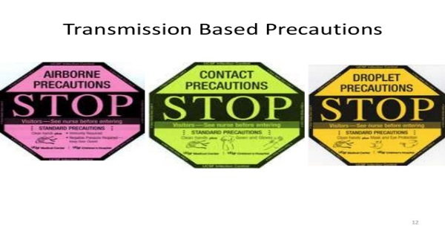](https://www.google.co.ke/url?sa=i&url=https%3A%2F%2Fnursingmanthra.com%2F2017%2F09%2F16%2Ftypes-of-transmission-based-precautions%2F&psig=AOvVaw06_lDw1wE1bBTNkJnOVunD&ust=1588322805956000&source=images&cd=vfe&ved=0CAIQjRxqFwoTCOiLrtnhj-kCFQAAAAAdAAAAABAJ)